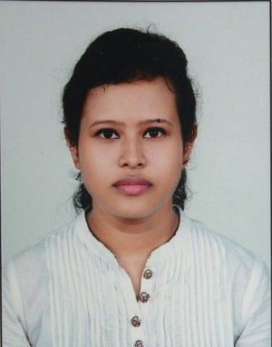

SUTANUKA DUTTA
: +91 - 9804909092
: sutanuka00@gmail.com
: https://in.linkedin.com/pub/sutanuka-dutta/91/38/431

My career objective is to procure a position in a company in the field of HR / Marketing and serve the organization on a long term basis with my knowledge and strategies.
WORK EXPERIENCE

Organization: 2COMS Consulting Pvt ltd.
Designation: Corporate HR Recruiter
Department: Internal & External Recruiter & BDE
Location: Kolkata
Duration: 06 September 2016 - Till date

- Look after the End to End recruitment.
- Doing the Business Development.
- Co-ordinating with the company and with candidates after selection.
- Maintaining daily/ weekly/monthly reports such as interview status reports, closure reports & feedback reports.
- Utilize various sourcing method like Web portals(Naukri, Monster, Times job, Indeed, LinkedIn)
- Taking Initial Interviews (Telephonic & F-F Round)
- Screening & short-listing candidates profile as per the requirements of client.
- Preparing candidates for interviewing with the clients by providing detailed information -business strategy, job descriptions, and expectation.

Previous organization

Organization: Axis securities Limited
Designation: Sales Executive
Department: Retail Broking
Location: Kolkata
Duration: 02 August 2015- 17 June 2016

- Responsible for selling the Online Trading department of Axis Bank
- I had 3 Branches of Axis Bank under me
- Dealing Business-to-end customer requirement
- Execute sales of new Demat & Trading Accounts
- Maintain the Customer relationship for long term basis
SUMMER INTERNSHIP/ PROJECT

Organization: Pantaloons Retail Pvt. Ltd. (Aditya Birla Group)
Duration: April - August, 2014
Location: Kolkata
Project Title: Comparative Study and Research on Private Label Brands and Others Brands in Pantaloons

- To understand which brands (pvt. or others) customers are more eager to buy.
- Identify factors that compel them to buy more.

ACADEMIC PROFILE

- PGDM (Retail and Marketing) from Institute of Engineering and Management, Kolkata (AICTE Approved) with 71 % in 2013-2015
- Graduation-Journalism & Mass Communication (H) from Vivekananda College, Thakurpukur (affiliated to Calcutta University) with 60 % in 2009-2011
- XII from Barisha Girls High School (West Bengal Council of Higher Secondary Education) with 69 % in 2008
- X from Barisha Girls High School (West Bengal Board Of Secondary Education) with 59 % in 2006

CERTIFIED DIPLOMA

1 year Diploma Course on Photography & Videography from Vivekananda College (UGC Sponsored) in 2011 with 80 %

PERSONAL DETAILS

Date of Birth: 13th November 1989
Permanent Address: 237, Bidhu Bhusan Sengupta Road, Behala, Kolkata-700034
Languages Known: English, Hindi and Bengali
Location Preference: Kolkata/Others
Interest: Photography, Traveling, Sports.
Passport Details: Expiry date  16/12/2023

